UBER SUPPLY DEMAND GAP ANALYSIS
Exploratory Data Analysis (EDA) Report
Analysis By - Nikhil Yadav
Date of Submission: 10-07-2026

Tools I Have Used:
- MS Excel
- SQL (DBeaver)
- Python (Pandas, Matplotlib, Seaborn)
- VS Code

1. Project Overview
Objective
The objective of this project is to analyze Uber ride request data to identify the gap between customer demand and driver supply. The analysis focuses on ride completion, cancellations, unavailable cars, demand patterns across pickup locations, time slots, weekdays, and hourly trends.

2. Dataset Information
Dataset Name: Uber Request Data
Total Records: 6745
Columns:
- Request ID
- Pickup Point
- Driver ID
- Status
- Request Timestamp
- Drop Timestamp

Additional Columns & Rows Created:
- Request Hour
- Request Date
- Day Name
- Time Slot

3. Data Cleaning
The following preprocessing steps were performed.
- Converted timestamps into Date-Time format
- Extracted Hour
- Extracted Date
- Created Day Name
- Created Time Slot
- Checked Missing Values
- Verified Duplicate Records
- Imported dataset into SQLite

4. SQL Analysis
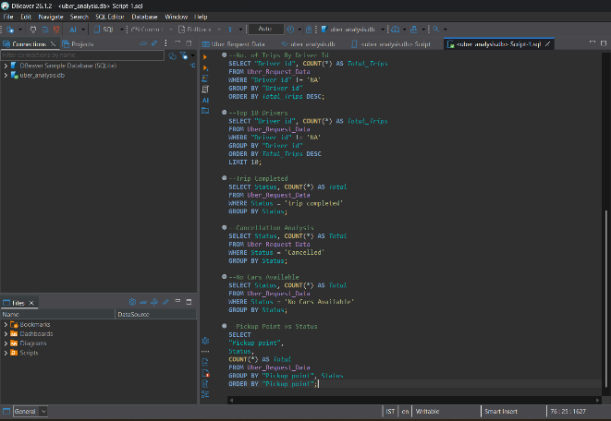
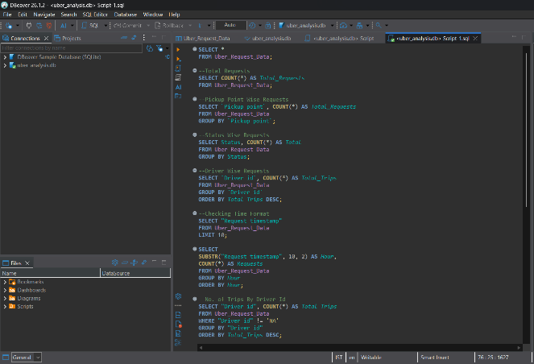

The following SQL queries were executed.
- Ride Status Distribution
- Pickup Point Analysis
- Driver-wise Trip Analysis
- Hourly Ride Requests
- Time Slot Analysis
- Cancellation Analysis
- No Cars Available Analysis
- Completion Rate Analysis

5. Exploratory Data Analysis
KPI Summary
Metric | Value
Total Requests | 6745
Trip Completed | 2831
Cancelled | 1264
No Cars Available | 2650
Completion Rate | 42%

6. Dashboard Analysis

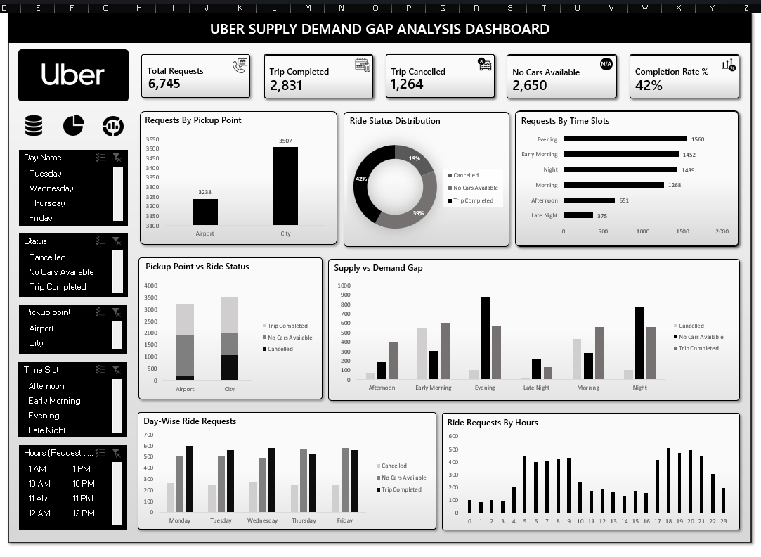

A. Ride Status Distribution
Completed | Cancelled | No Cars Available
2831 | 1264 | 2650

Insight
Only 42% of rides were completed.
Nearly 58% of requests failed because of either:
- Driver Cancellation
- No Cars Available
This indicates a significant demand-supply imbalance.

B. Pickup Point Analysis
Airport Requests | City Requests
3238 | 3507

Insight
The City generated slightly higher ride demand than the Airport.
Demand is almost equally distributed across both pickup locations.

C. Pickup Point vs Ride Status
Airport:
Completed rides are comparatively lower than unavailable cars.
Large number of customers could not get a ride.
City:
Driver cancellations are significantly higher.
This indicates driver reluctance after accepting rides.

D. Ride Requests by Time Slot
- Highest Demand
Evening - 1560
Early Morning - 1452
Night – 1439
- Lowest
Late Night - 375

Insight
Demand peaks during:
- Evening
- Early Morning
Supply planning should mainly focus on these periods.

E. Supply vs Demand Gap
- Largest gap observed during:
Evening
Morning
Early Morning
- Reason:
High customer demand
Limited driver availability
Frequent ride cancellations

F. Day-wise Ride Requests
Demand remains fairly consistent across weekdays.
No major weekday variation observed.

G. Hourly Ride Requests
- Highest demand hours
5 PM – 10 PM
- Morning Peak
5 AM – 9 AM
- Lowest demand
12 AM – 4 AM

7. Python EDA Findings
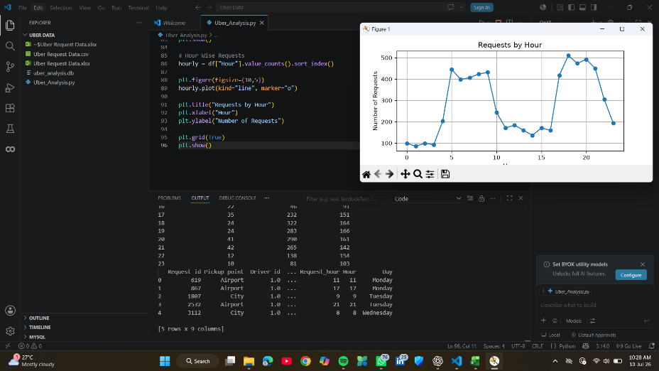

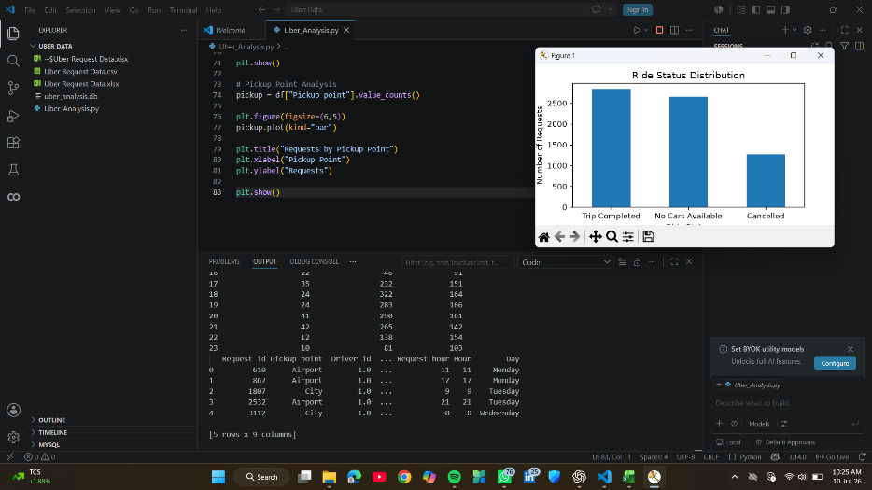

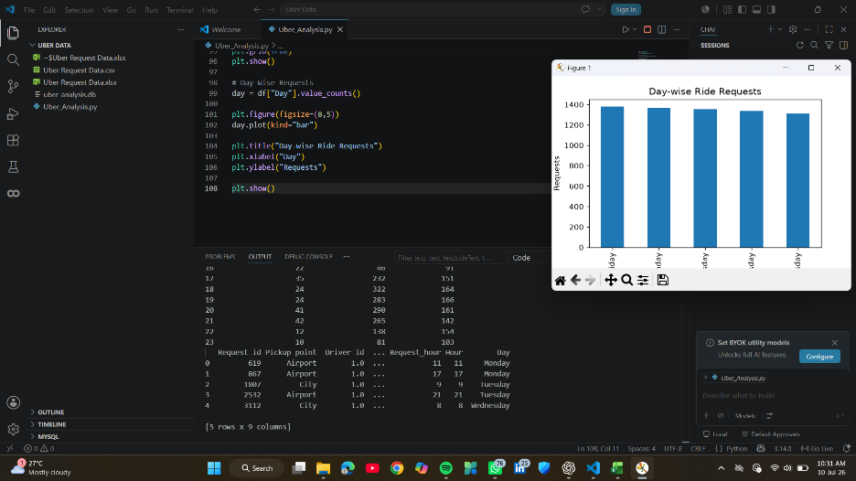

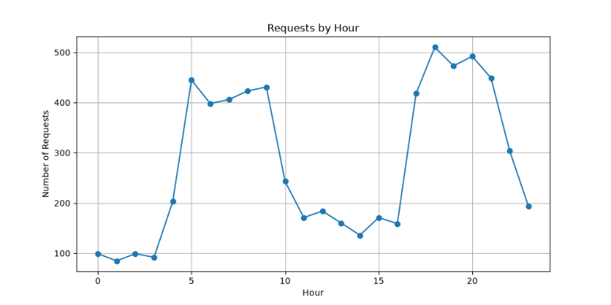

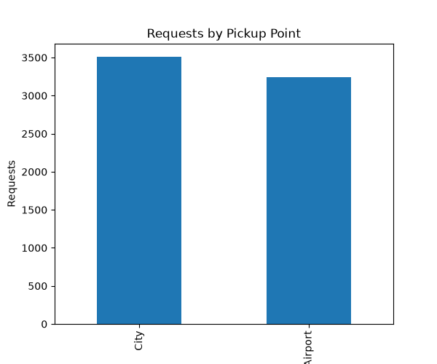
Requests By Hour

Requests By Pickup Point
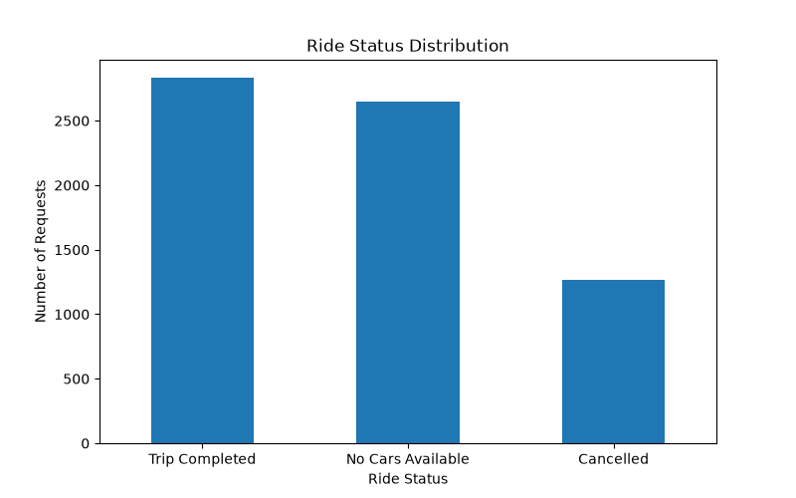

Ride Status Distribution

Python visualizations confirmed the dashboard observations.
- Bar Charts
- Pie Charts
- Countplots
- Hourly Analysis
- Status Distribution
- Pickup Point Analysis
All charts consistently showed:
- Evening demand peak
- Morning demand peak
- High No Cars Available
- High cancellation rates

8. Business Insights
Insight 1
Demand exceeds supply during Evening and Morning hours.

Insight 2
No Cars Available (2650 rides) is the biggest contributor to lost revenue.

Insight 3
Driver cancellations remain high in City pickups.

Insight 4
Completion Rate of only 42% indicates poor operational efficiency.

Insight 5
Airport demand remains consistently high and requires additional drivers.

9. Recommendations
- Increase Driver Availability
Deploy more drivers during Morning, Evening, Airport peak hours

- Reduce Driver Cancellations
Performance incentives
Penalty system
Acceptance rate monitoring

- Dynamic Pricing
Apply surge pricing during Morning & Evening Peak to encourage more drivers.

- Demand Forecasting
Use historical demand to predict Peak Hours, Peak Days, Peak Pickup Locations

- Driver Allocation
Allocate idle drivers toward Airport in Evening & Morning demand.

10. Project Conclusion
The analysis reveals that Uber experiences a significant demand-supply mismatch.
Although customer demand remains consistently high, limited driver availability and frequent ride cancellations reduce the overall completion rate to 42%.
Improving driver allocation, reducing cancellations, and increasing supply during peak hours can significantly improve customer satisfaction and business performance.

11. Final Conclusions & Recommendations:
Top 3 Problems
- Airport Evening Supply Crisis: 70% of demand at the airport remains unmet between 5 PM and 10 PM.
- City Morning Cancellations: Drivers cancel 26% of rides in the city between 5 AM and 9 AM.
- Overall 58% Revenue Loss: 6 out of every 10 customers are not receiving service.

12. Data-Driven Solutions for Uber:
- Surge Pricing at Airport 5-10 PM: Increase incentives for airport pickup to help drivers cover the loss of returning empty.
- 2. Driver Penalty for City Cancels: Implement driver rating/fine for morning cancellations in the city.
- 3. Pre-booking for Airport: Provide vehicle wait times at the airport in advance based on flights.
- 4. Shift Drivers: Give drivers a bonus for staying in the airport zone between 4-10 PM.

